UCS C-Series C220 M3S Firmware Upgrade to 2.0(8d)

**Version: 1.0**

**Date: 03/14/2017**

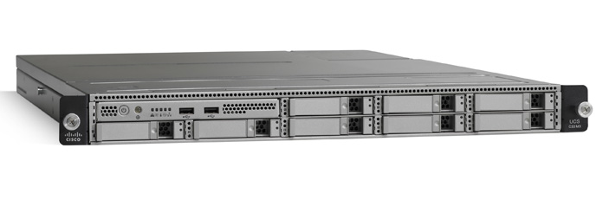

**Table of Contents**

1. Overview 3

2. Preparation 4

2.1. Download HUU ISO File 2

2.2. Prepare the ISO for a remote upgrade using the KVM Console 2

2.3. Boot the server 3

2.4. Boot the server and press F6 when prompted to open the Boot Menu screen. 4

2.5. Select appropriate update options and select ‘Update All’ 5

2.6. Log back into CIMC 9

**References:**

* <http://www.cisco.com/c/en/us/td/docs/unified_computing/ucs/release/notes/Release_Notes_for_Cisco_C-Series_SW_2_0_8.html>

# Overview

This runbook describes the detailed tasks to upgrade the UCS C-series Firmware to 2.0(8d). The upgrade is required to for following:

# Preparation

## Download HUU ISO File

Download the HUU ISO file:

* Navigate to the following URL: [http:/​/​www.cisco.com/​cisco/​software/​navigator.html](http://www.cisco.com/cisco/software/navigator.html).
* In the middle column, click **Servers – Unified Computing**.
* In the right-hand column, click **Cisco UCS C-Series Rack-Mount Standalone Server Software**.
* Choose the name of your model of server in the right column.
* Click **Unified Computing System (UCS) Server Firmware**.
* Choose the release number.
* Click **Download Now** to download the ucs-server platform-huu-version_number.iso file.
* Verify the information on the next page, and click **Proceed With Download**.
* Continue through the subsequent screens to accept the license agreement and browse to a location where you want to save the file.

## Prepare the ISO for a remote upgrade using the KVM Console

* Use a browser to connect to the Cisco IMC GUI software on the server that you are upgrading.
* In the address field of the browser, enter the Cisco IMC IP address for that server, and then enter your username and password.
* Click Launch KVM Console on the toolbar to launch the KVM Console.

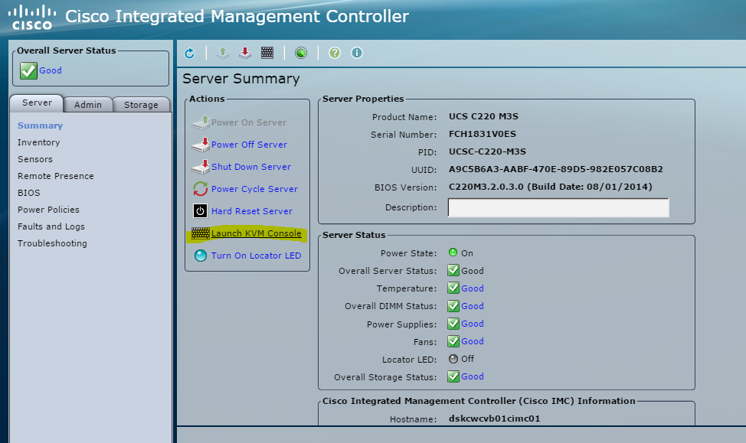

NOTE: The current CIMC version can be found on the login screen and on the ‘Server🡪Summary’ screen. A more detailed summary of firmware running on the system is available in the ‘Admin🡪 Firmware Management’ menu.

* In the KVM Console, click the Virtual Media.
* Click Add Image and click the ucs-server-name-huu-version_number.iso file.
* wait for mapping to complete.

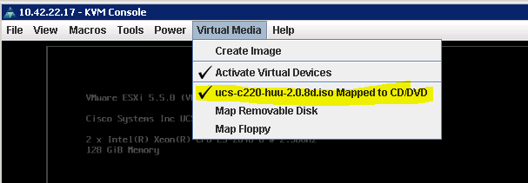

* After the ISO file appears as a mapped remote device, go to Step 2.3.

## Boot the server

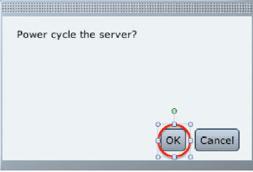

## Boot the server and press F6 when prompted to open the Boot Menu screen.

* In the Boot Menu screen, choose the prepared ISO:
* For a remote upgrade, choose Cisco vKVM-Mapped DVD1.22, and press Enter.
* The server boots from the selected device.

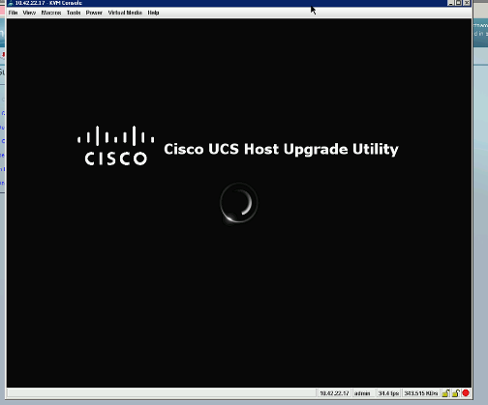

* After the HUU boots, Cisco End User License Agreement (EULA) appears, read the EULA and click:
* I Agree to agree with the license agreement and proceed with the update.
* After you accept the EULA, when the Cisco Host Upgrade Utility window appears with a list of all the components that are available for update.

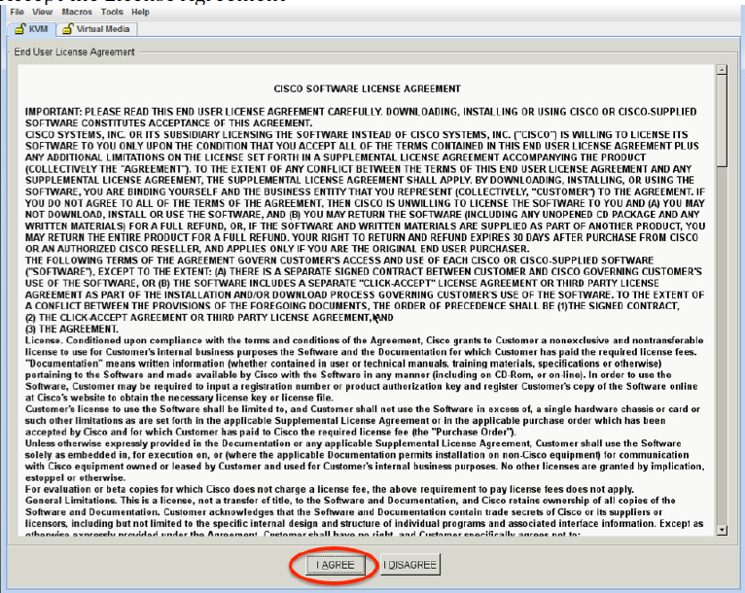

## Select appropriate update options and select ‘Update All’

NOTE:

* During update the KVM connection will be lost, you have to reconnect to view the progress of the updates.
* **Enabling Cisco IMC Secure Boot** confirmation dialog box appears. Read the content on the confirmation box carefully and click yes, if you want to go ahead and update the firmware and enable Cisco Secure Boot.

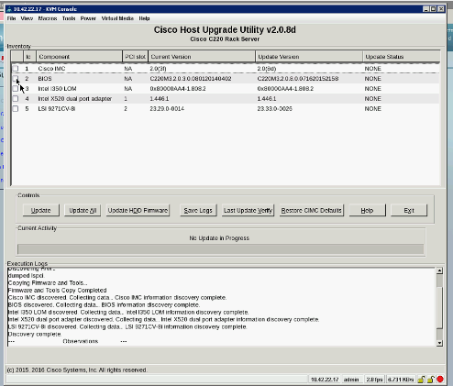

* If ‘Update All’ is selected this notification will need to be acknowledge

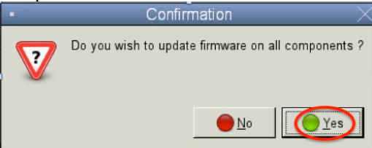

* Acknowledge updates in queue and select ‘Yes’ to proceed
* Once all updates (except BIOS) are applied, the system should prompt user a final time for acknowledgement of BIOS update and system reboot. Once this acknowledgement happens the tool will complete the BIOS update and reboot the system and CIMC – causing the installer to exit.

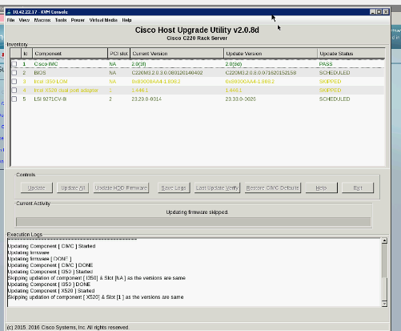

NOTE:

* In case of C460 M2 and C260 M2, this question will not be asked as the update is done while the host is powered on. The following scenario is only applicable for C22 M3, C24 M3, C220 M3, C240 M3 and C420 M3.
* The system will power-cycle and the CIMC will reboot on updated version of software. This will cause the KVM session to disconnect.

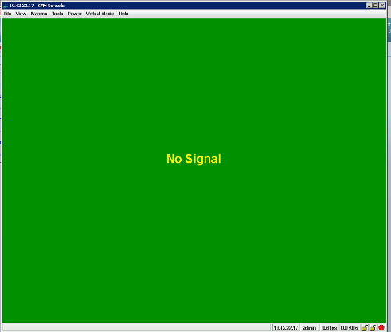

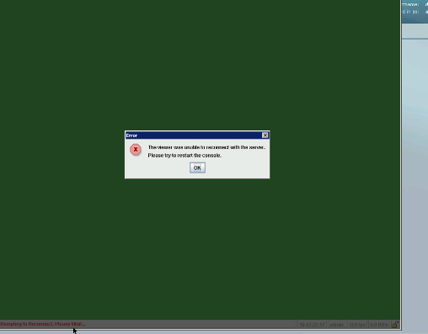

## Log back into CIMC

